**Eat Out to Help Out Guide (Created by Simray, 4 Aug 2020, edited 8 Aug 2020 1623 GMT+1 [v1.3])**

# CONTENTS

1) Source of data 2

2) Extracting data from the site to .csv format 3

3) Creating a personal Google Map 6

4) Troubleshooting problems 7

# Source of data

The data we will use is retrieved from the UK government’s official website:

<https://www.tax.service.gov.uk/eat-out-to-help-out/find-a-restaurant>

The website allows users to input their postcode. It will return the list of restaurants participating in the Eat Out to Help Out scheme within 5 miles of the specified postcode.

In this example, we will be using the postcode "L39 4QP" for demonstration purposes.

Results obtained shows 80 restaurants within 5 miles of L39 4QP (Figure 1).

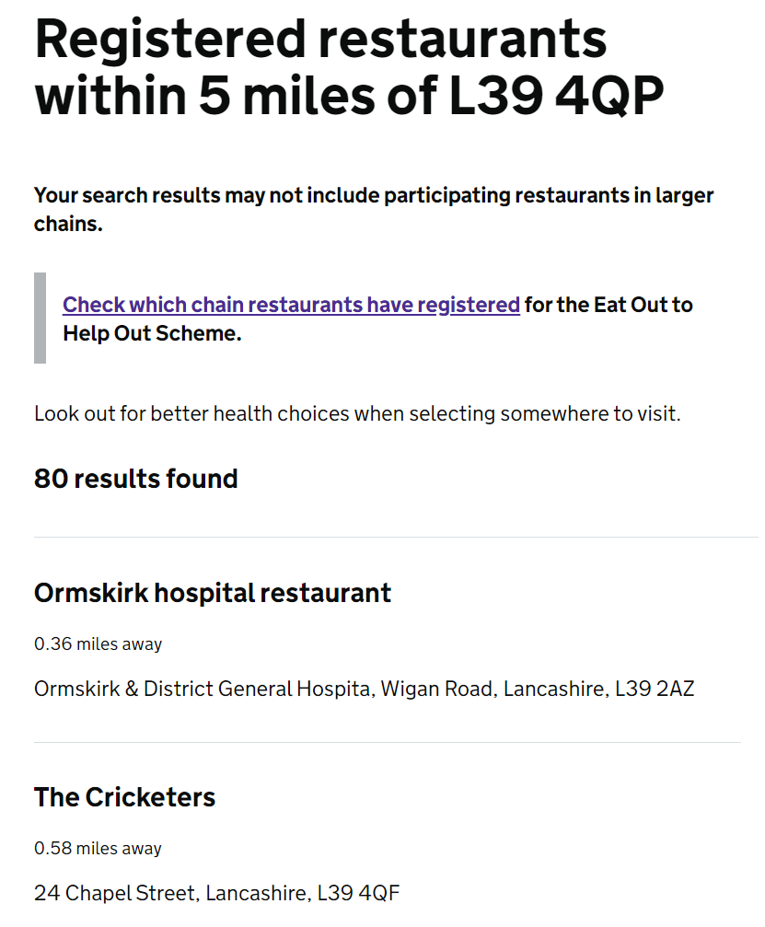

Figure 1: Participating restaurants within 5 miles of the specified postcode.

# Extracting data from the site to .csv format

Now, we will have to use the code from the code file "EatOutToHelpOut.py" located in the repo and run it through a python platform to extract and parse the "Name" and "Address" of the participating eateries into a .csv file. All you need to do is to run it and input your postcode.

Note: You will have to do a pip install of the modules (csv, requests, html) that are required if you do not have them!

|  |
| --- |
| **import** **requests**  **import** **html**  **import** **csv**  # The script will ask you to input your post code.  **print**("Please enter your post code.")  **print**("Please note that spacing is required.")  **print**("E.g. 'L39 4QP'**\n**")  **print**('Enter your post code:')  postcode = input()  postcode = str(postcode)  # This is to create a .csv file in the script's directory, with the file name being the post code specified.  f = open(postcode + '.csv', 'w', newline='')  csvwriter = csv.writer(f, delimiter=",")  f.write("Name, Address**\n**")  # The list of registered restaurants within 5 miles of the specified postcode will be obtained from the government website.  postcode = postcode.split(' ')  url = 'https://www.tax.service.gov.uk/eat-out-to-help-out/find-a-restaurant/results?lookup=' + \  postcode[**0**] + '+' + postcode[**1**]  r = requests.get(url)  r = r.text  # The script will extract the site's data to obtain the restaurant's name and its corresponding address.  **for** line **in** r.splitlines():  **if** '<h3 class="govuk-heading-m"' **in** line:  y = line.split('>')[**1**]  y = y.split('<')[**0**]  y = html.unescape(y)  **if** 'govuk-results-address govuk-body' **in** line:  x = line.split('>')[**1**]  x = x.split('<')[**0**]  x = html.unescape(x)  result = (y, x)  **print**(result)  csvwriter.writerow(result)  **print**('**\n**')  **print**(str(postcode[**0**] + ' '+postcode[**1**]) +  '.csv has been created on your computer. You may now import the .csv file into google maps.')  **print**('If your .csv file is empty, please check if there are indeed participating restaurants in your area.')  f.close() |

After running the code, simply input the post code (Figure 2) that you would like to check the participating restaurants and a .csv file will be automatically created and saved. You will have to locate it in your computer.

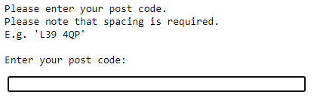

Figure 2: Output for entering post code

I usually locate the newly-created .csv file (Figure 3) by just pressing my Windows key and searching for the document "L39 4QP.csv", before moving it to somewhere accessible.

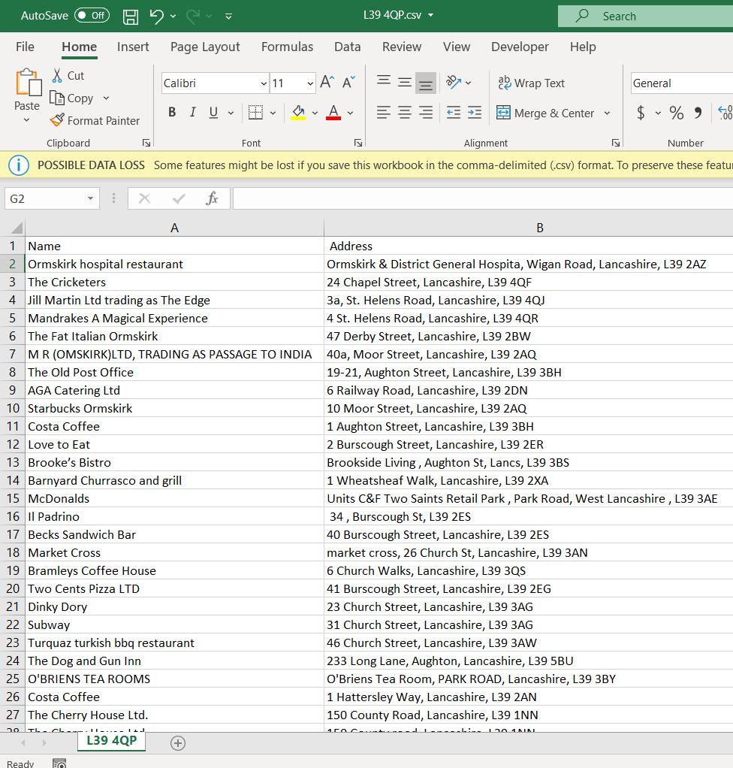

Figure 3: .csv file containing “Name” and “Address” of the participating restaurants

# Creating a personal Google Map

1. Go to [Google Maps](https://www.google.com/maps), select the "Menu" tab on the top left, select "Your places", go to the "MAPS" tab and select "CREATE MAP"
2. Click on "Import", "Select a file from your device", find your .csv file and open it
3. For "Choose columns to position your placemarks", select "Address" and click on "Continue"
4. For "Choose a column to title your markers", select "Name" and click on "Finish". Now it will show all the places that was listed on the website (Figure 4)!

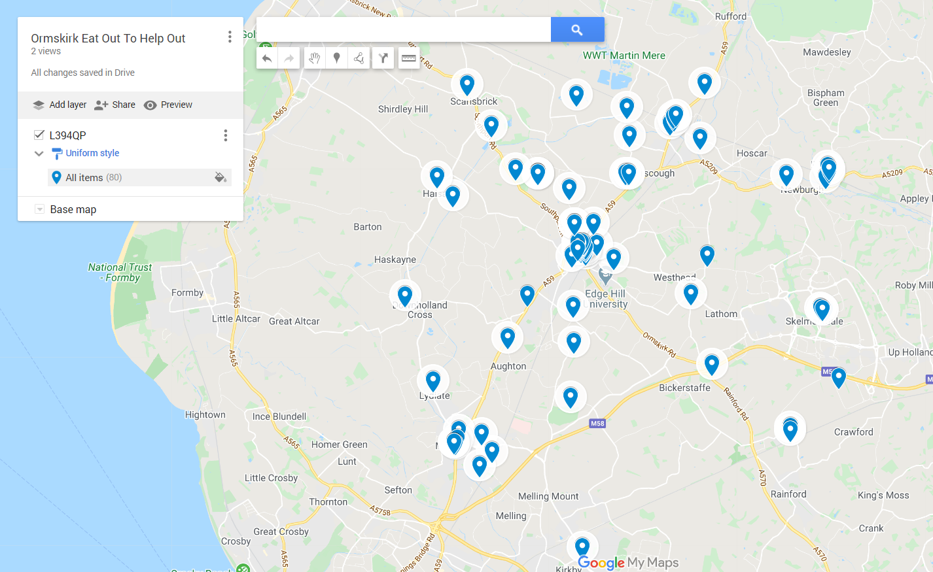Figure 3: Visualisation of participating restaurants on Google Maps

# Troubleshooting problems

There were a few situations where I was helping my friend load the places near them and there were some that were not loaded. This can be rectified manually and it is usually around 0-3 incidences per 100 samples.

Unfortunately, we have not found a way to link these destinations with the actual Google Maps business page. We will need to take a look at this and perhaps if someone in the community knows how to solve this issue that would be great!

For now, what we have is a code that can visualize the restaurants participating in the scheme!